**Date:** 13 October 2025

**Location:** Aptech Pakistan

**Instructor:** Sir Hafizullah Khokhar

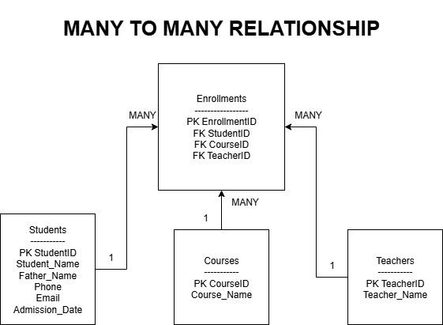

This ER Diagram shows a **Many to Many Relationship** between **Students**, **Courses**, and **Teachers** using the **Enrollments** table.

* One **Student** can join many **Courses**.
* One **Course** can have many **Students**.
* One **Teacher** can teach many students in different courses.
* StudentID, CourseID, and TeacherID is the **Primary Key** in the Enrollments table.
* StudentID, CourseID, and TeacherID also are the **Foreign Keys** in the Enrollments table.
* The lines between the tables are labeled **1..MANY**, which means one record in Students, Courses, or Teachers is connected to many records in Enrollments.